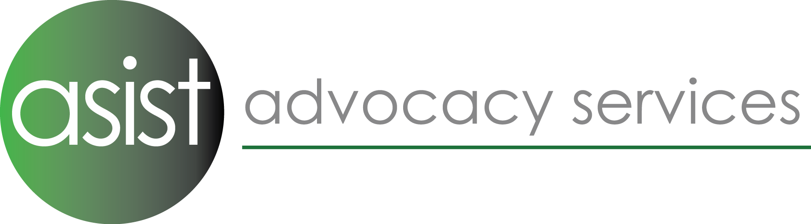

Administrator: Staffordshire Hub Team

Job description

Responsible to: Team Leader

Overall Purpose: As directed by the Team Leader, to provide administrative support to the team and the Advocacy Hub.

Principal Accountabilities:
Office Duties

- Assist the Team Leader with office administration.
- Respond to incoming enquires by phone, post, e-mail, fax and website.

Key performance Indicators (KPI)

- Calls and enquiries responded to in a timely manner and logged onto database system.
- To maintain an up to date list of useful signposting organisations across the localities for referral on as appropriate; ensuring that updated information is gathered and recorded on the database system.

Project Support

- Assist the Team Leader in providing administrative support for the team and support with team meetings, awareness raising etc.

Key performance Indicators (KPI)

- Meetings are recorded and logged onto the SharePoint/Database system.

Information & Reporting

- Administer receipt of referrals into the service, enter referrals and with support from the manager or experienced team member, establish eligibility and enter referral data onto online database system.
- Checking information recorded on database is accurate.
- Collating and requesting feedback from stakeholders.

Key performance Indicators (KPI)

- Referrals logged onto database system within service contract specification, gaps in information completed and followed up with the referring party.

Finances

- Liaison with commissioners regarding arrangement for payment of service as required.
- Act as main contact for collating data and reporting on advocacy case work undertaken for the purpose of raising invoices.

Key performance Indicators (KPI)

- Invoices for Spot-Purchased work – submitted on a monthly basis.

Organisational

- Adhere to Asist‘s policies and procedures, including Equality of Opportunity, Confidentiality, etc.
- Keep up to date with knowledge of eligibility criteria and sign-posting.
- Maintain appropriate levels of confidentiality.
- Be involved in your own professional development.
- Other duties in line with grade of this post, including co-working with other administrators where necessary.

Personal Qualities
Skills | Essential | Desirable | Measured By
Skills | Essential | Desirable | Application | Interview | References
Work Experience | - Experience of undertaking administrative support to management  - Teamwork skills  - Knowledge of invoicing, use of Excel and spreadsheets.  - Methodical and accurate working with large sets of information | - Experience of voluntary sector organisations  - Experience of working with people with disabilities
Organisational | - Organisational skills  - Time management skills  - Computer skills | - Experience of organising meetings
Qualifications | - Administration NVQ Level 2 or similar
Personal | - Good communication and listening skills  - Good liaising skills with staff, service users and professionals  - Diplomatic and empathic disposition towards people who are using Asist’s services
Miscellaneous | - A demonstrable belief in the aims and objectives/values of advocacy organisations within the voluntary sector  - Commitment to anti-discriminatory/oppressive practice | Knowledge and experience of advocacy issues  - Knowledge of Mental Capacity Act 2007

